**Annual Report 2022-2023**

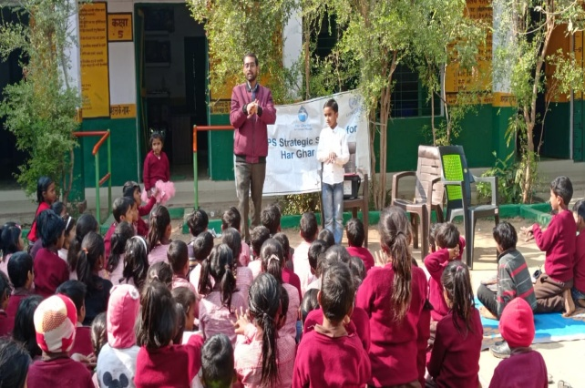



**Institute for Development Support (IDS)**

**Annual Report 2022-2023**

## A BRIEF PROFILE OF INSTITUTE FOR DEVELOPMENT SUPPORT

Institute for Development Support (I.D.S) is a registered autonomous non-governmental organization, established in 1993-94 and based in Pauri Garhwal, Uttarakahnd. IDS works with rural, urban communities of the Himalayan region with the prime motto of empowerment of the society. The organization believes in an integrated development of Man and Nature and actively involves the stakeholders in implementation of innovative programs in the rural, urban areas of Uttarakhand. IDS mantra is to facilitate mountain communities to know and understand their own strength so that they could participate in the developmental and environmental activities. The organization aims at helping people utilize their inherent potential to improve their well-being through self awareness and use of traditional wisdom. IDS has multidisciplinary team of professionals including development planners, extension workers and trainers having many years of experience in project development, implementation, capacity building, monitoring and evaluation.

## Vision of the organization

To create an empowered and self reliant society

## Mission of the organization

To develop and implement innovative, multidisciplinary developmental programs that are sustainable and replicable.

**Objectives of the organization**

* To improve socio-economic status of the society.
* To Implement integrated rural development programs for the sustainable development of the society
* To organize capacity building programs for the enhancement of knowledge, skill and entrepreneurship development.
* To create awareness and plan, implement, monitor and evaluate programs related to Education, health, Livelihood, and environment rehabilitation
* To build capacity of community based organization, women groups and panchayati raj institutions in natural resource management.
* To implement awareness programs for the eradication of various social evils prevailing in the society.
* To introduce various appropriate technologies such as rain water harvesting, biogas, solar energy, composting, solid, liquid waste management, pasture and fodder development, soil-water conservation etc.
* Publication and production of books, magazines, newsletters, posters, films, audios and videos.

**Partners**

* United Nations office for Project Services (UNOPS)
* Water Supply and Sanitation Collaborative Council, an UN unit
* UNIDO (United nation Industrial Development Organization, Vienna, Austria )
* Integrated Livelihood Support Program-IFAD, Govt of Uttarakhand
* Uttarakhand Tourism Development Board, Govt of Uttarakhand
* WISIONS,Wuppertal Institute for Climate, Environment and Energy, Germany
* IIMPACT, Gurugram Haryana.
* Indo German Energy Program, GIZ, New Delhi
* National Bank for Agriculture and Rural Development (NABARD)
* Forest Department, Government of Uttarakhand
* Jal Sansthan and Jal Nigam, Government of Uttarakhand
* District Administration, Pauri Garhwal
* Health Department, Government of Uttarakhand
* Sir Ratan Tata Trust (SRTT), Mumbai
* District Project Management Unit (DPMU), SWAJAL, Department of Drinking Water, Government of Uttarakhand
* Uttarakhand Renewable Energy Development Agency (UREDA), Government of Uttarakhand
* Shri BhuvneshwariMahila Ashram/ PLAN International
* World Vision, Pauri Garhwal
* Department of Science and Technology, Govt. of India
* Indian Institute of Technology, Roorkee
* CDM Smith Associates Inc. Banglore.
* HIFEED, Ranichounri, Tehri Garhwal
* M/S Karvy Pvt Ltd
* Centre for Environmental Education, Lucknow
* IT Power synergy services Ltd, Gurgoan
* Department of Planning and Statistics, GoUK
* IL&FS Pvt. Limited, New Delhi

Institute for Development Support is working in more than 200 villages of 12 districts of Uttarakhand and slum area of Delhi in the following areas.

1. **Economic Empowerment:** The program is focused to promote agriculture & horticulture based livelihood of the local community, training, capacity building, and vocational training to youths on different livelihood options. In addition to this the program is also focused to establish the community based micro finance groups or women SHGs engaged in micro enterprises for their livelihood enhancement. Many trainings and capacity building programs were organized in vegetable farming, bee keeping, dairy development, spices cultivation, mushroom farming, fruit processing, nursery development, poultry, marketing of the products and non farm activities such as re-cycling of waste material and development of products in rural and urban areas.
2. **Community Based Tourism:**IDS has been engaged in planning, implementation, monitoring and supervision of community based tourism activities in 12 districts of Uttarakhand for livelihood enhancement. The key activities being performed under the projects are identification of suitable villages for tourism development, IEC, formation and management of village tourism development committee, eco development committee, identification of their training need, designining and implementation of training in hospitability management, cooking, bird watching, interpretation, nature guiding, low cost dwelling units, business plan preparation, linkages with parytanswarojgaryojna and established linkages with marketing agencies.
3. **Water & Environment Sanitation:** IDS has facilitated planning and implementation of many rural water and environmental sanitation schemes in the villages of Uttarakhand supported under Sector Wide Approach and total sanitation campaign. IDS empowered community based organization particularly village water and sanitation committees to execute safe water supply and sanitation program for sustainable health and hygiene. An innovative, solar lifting water scheme was also constructed to fulfill the need and demand of the villagers. Apart from this, IDS is facilitating construction of household sanitary toilets, school sanitation and environmental sanitation.
4. **Gender Empowerment:** Under this program, the organization is generating awareness among community members, PRIs, women groups, government officials/institutions, children groups on gender equity and equality. Capacity building training of youth & women on different issues/skills, government law & policies are also the part of the program.
5. **Renewable energy for livelihood development:** Organization is engaged in implementation of programs that promote clean, green renewable energy to mitigate the adverse impact of climate change. To generate awareness among community members about green energy, IDS has organized several Green techno fairs or exhibition in Uttarakhand. Traditionally watermills have been source of clean energy and mechanical power to grind food grains in Uttarakhand. IDS has also been engaged in installation of model water mill and improvement of traditional water mill for electricity generation as well. The local communities residing nearby the watermill were organized into SHGs for the processing, packaging marketing of watermill processed products for livelihood enhancement.
6. **Education & Health Program**: IDS is regularly involved into improvement in formal and informal education program with communities. Organization operating 130 Education Center for the girl child who could not attended formal schooling or drop out from the school in Dehradun and Himachal. Apart from this IDS also promoted eco clubs in the 150 school for imparting better environmental education to children. Child right is another key area where organization has organized many advocacy programs. IDS implemented reproductive child health program that include preparation of birth plans, educating & mobilizing mothers for early registration, complete vaccination, IFA distribution, institution delivery and other health & hygiene issues. In addition to this the program is also focused to educate adolescents on reproductive & sexual health, conduction of health camps in remote area, regular school level camps, regular counseling, eradication of female foeticide and treatment of mal-nourished children etc.
7. **Natural Resource management**

The economy of Uttarakhand is more dependent on natural resources. The condition of the natural resources is deteriorating day by day. Considering the facts, IDS have been regularly engaged in conservation and protection of natural resource through community institution such as van panchayats, PRI, SHGs and Mahila Mangal Dals. The key program organized under the components are formation and strengthening of van panchayats, imparted different capacity building trainings to committee members and villagers, supported to committee members for nursery development, plantation, trenching, construction of ponds and rain water harvesting tanks.

**Management structure**

The executive board of the IDS is apex body which provides guidance and takes final decision regarding growth of the institution. The Executive Director nominated by the apex body is responsible for the implementation of the decision taken by the board. Executive Director provides guidance and assistance to staff, project team and field facilitator for effective planning and implementation of the programs. IDS has separate Project Coordinator or Team Leader and experts for the projects being implemented by the IDS.

Executive Body

Executive Director

Program Coordinator

Program Coordinator

Program Coordinator

Field Facilitators

Field Facilitators

Field Facilitators

Admin &Finance Officer

Subject specialist

**Summary of projects Activities carried out by Institute for Development Support during 2022-23**

|  |  |  |  |
| --- | --- | --- | --- |
| **S.N.** | **Project name/ Place** | **Beneficiary** | **Funding from** |
| 1 | Provision of capacity building management and support for the implementation of Jal Jeevan Mission (Rural Water Supply Program): Uttar Pradesh_Phase-II | Rural community of UP | United Nations Office for Project Services (UNOPS) |
| 2 | Provision of capacity building management and support for the implementation of Jal Jeevan Mission (Rural Water Supply Program): Assam | Rural community of Assam |  |
| 3 | Provision of capacity building management and support for the implementation of Jal Jeevan Mission (Rural Water Supply Program): Rajasthan | Rural community of Rajasthan |  |
| 4 | Girls Child EducationProgram | 35 villages of Dehradun and 45 villages of Mori block of Uttarkashi | IIMPACT, Gurugram, Haryana |

***PROJECT-1* Provision of capacity building management and support for the implementation of Jal Jeevan Mission (Rural Water Supply Program): Uttar Pradesh_Phase-II**

**Following activities have been conducted by IDS during reporting period.**

1. **Orientation training for existing staff**

In order to build the capacity of the existing staff, IDS has organized a 5 days training program at Lucknow during 16 to 20 November 2022 on implementation of JJM activities in 137 villages of 11 districts. To prepare training modules and conduct training for the staff, UNOPS/IDS have engaged retainers of UNOPS. The scheduled of the training program was prepared on the basis of following Topics.

1. JJM vision, mission, strategy, components and the key interventions at HH and community level.

2. Community approaches to ensuring water security and sustainability at the village level.

3. Participatory approaches such as CLNOB and CLAS S for participatory data collection at the community level followed by community analysis and mobilization

4. Planning, design, implementation and operation and maintenance of water supply schemes and systems with focus on operation and maintenance (O&M) planning and monitoring at the

community level

5. Key issues in water security and sustainability including: source sustainability; water conservation; water recharge; grey water management; rainwater harvesting, water quality monitoring, surveillance, solid and liquid waste management etc.

6. Appropriate and cost-effective technologies for rain water harvesting, catchment protection, grey water management, ODF sustainability, fecal sludge management etc.

6. Implementation of VAP and linking with the GPDP

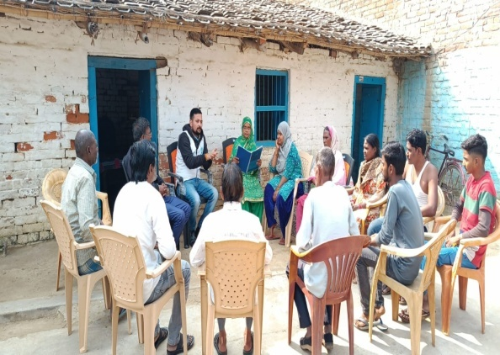7. Roles and responsibilities of CDCs in implementation phase

7. Preparation of action plans

1. **Meeting with VWSC for updation of GPDP**

Following the training and joining their respective duty places, CDCs organized village wise VWSC meetings to prioritize the activities to be included in the GPDP. CDCs has briefed VWSCs/communities regarding activities taken under the GPDP by showing them E-Swaraj portal and then asked to identify and make community consensus for the most needed activities to be included in GPDP. The meeting were held in presence of secretary to Gram Panchayat. The identified activities will be uploaded by the secretary at the e-swaraj portal.

1. **VAP Revision**

District Consultant completed the VAP revision exercise in all the intervention village of 11 districts. The objective of the activity was to revisit the VAP and make the necessary changes based on the need of the community. During the activity community members were made familiarized with the GPDP planning process and addition of VAP in the same for a year.

1. **School awareness activities**

District consultant carried out school awareness sessions from 9th to 19th December’22. The objective of the activity is to familiarize children with Jal Jeevan Mission and build their understanding on water conservation. Children in schools were also made familiarized with essential water quality mandates with help of FTK. Following 3 activities were taken place during the school awareness program

1. Prabhat Pheri
2. Water quality testing demonstration by FTK trained women
3. Drawing and poster competition

Activity was done in all the schools of project intervention area and total 12,282 children (6904 boys and 5378 girls) were sensitized during the activity.

1. 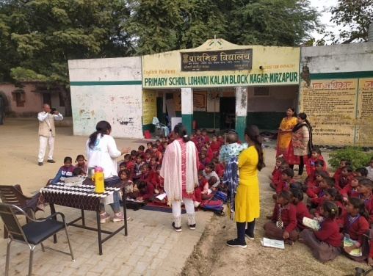**DOR Revision to ensure 100% FHTC**

In order to ensure the FHTC connection in 100% household of UNOPS intervention area, weeklong activity was done by District Consultant (DC) in the month of December. The process of the activity included

1. Review of DPR
2. Physical verification of the FHTC target in field
3. Acknowledge the actual target by village Pradhan
4. Submission of report to executive engineer/ADM
5. **ISA Handholding:** District consultant provided handholding support to ISA agencies for mobilizing community for FHTC and organizing school awareness sessions in Lohndi kala and Bharpura villages of City and Pahari block of Mirzapur district. During both the activities 91 male and 75 females were oriented on different agenda of JJM
6. **Community Led Action for Sanitary Surveillance (CLASS):**

List of activities under CLASS

District Consultant conducted CLASS activities in all intervention communities. The activity started from 12th January and completed on 10th March’23. The objective of the activity is to make the community acquaint with clean drinking water and safe water source. The activity provided hands-on training to community members to assess the status of drinking water sources and sanitation facilities of their villages. District consultant with the help of community members conducted series of activities in the field.

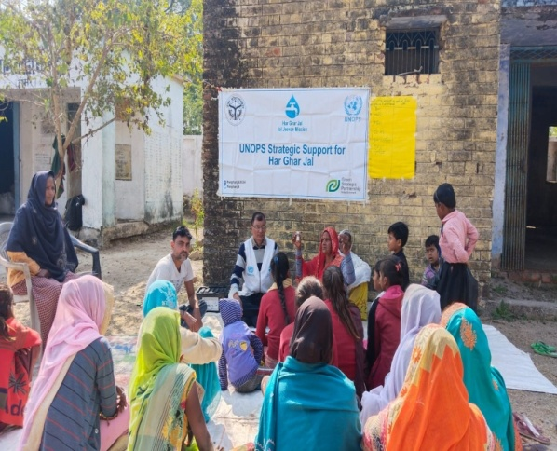**Disease mapping:** the participatory mapping exercise conducted to calculate the monthly/annual expenditure on water related diseases.

Disease mapping exercise in Hamirpur

**Bacteriological test:** the test was conducted via S2S vial in order to assess the bacteriological contamination of water sources.

**Chemical test:** the test was conducted via field testing kit (FTK). 3 samples from each village were tested on 10 parameters (i.e. Chloride, Hardness, Iron, Nitrate, Fluoride, Chlorine, PH, Turbidity, Alkalinity and Arsenic).

**Sanitary survey:** the physical verification of 3 positive water sources (Hand pumps) was done in all the intervention villages.

**Home based water treatment solution:** at the end of the activity DCs shared home based water treatment methods for rapid purification of water.

3 day long CLASS activity is completed in 137 intervention villages of Uttar Pradesh. Total 3640 participants (male & female) participated in the activity.

**2. PRJECT-2: Provision of capacity building management and support for the implementation of Jal Jeevan Mission (Rural Water Supply Program): Assam**

Following activities are carried out during the reporting period

1. **PREPARATION OF TOR AND ADVERTISEMENT OF THE POSTS**

Just after signing the agreement with the UNOPS, IDS has prepared a detailed ToR of the consultants proposed at state and District Level. An advertisement was published on [www.devnetjobsindia.com](http://www.devnetjobsindia.com) by Institute of Development Support (IDS), Dehradun to select the consultants to work on UNOPS funded project “capacity building management and support for the implementation of Jal Jeevan Mission (Rural Water Supply Program)” in 2 districts of Assam, India.

1. **SELECTION OF THE STAFF TO BE DEPLOYED UNDER THE ASSIGNMENT**

Total 43 applications were received, out of which 3 participants were shortlisted after two rounds of screening and telephonic conversations with shortlisted applicants. The First set of screening was done by reviewing their CV’s and the second was done by conducting telephonic interviews which had basic questions regarding WASH, their facilitation skills, learning and changes in their attitude, affordability and availability with their preference to work in remote locations which was further given weighted scores. Selected participants were professionals having sound backgrounds and were offered letters for joining IDS. Selected staff were invited to participate in the 5 days orientation training program at New Delhi.

## CONSULTANT'S ORIENTATION TRAINING

Along with the Rajasthan and Tamil Nadu teams, the Assam team attended a 5-day orientation training held on 6th-10th December 2022 in Delhi. The expert trainers and members of the national team oriented the teams on different aspects of the projects, their responsibilities on the field, and the processes involved in implementing those. On the first day of the training, all state and district coordinators were explained their roles and responsibilities, the role of ISAs, and the formation and function of the Village Water and Sanitation Committees (VWSC). On the second day, the expert trainers thoroughly introduced the participants to the Community Led No One Left Behind (CLNOB) process with mock drills and mechanisms for retrofitting toilets. On the third day, participants learned about the sustainability of toilets, Field Testing Kits through demonstration and the Community Led Water Quality Monitoring and Surveillance (CLASS) process. On day four, participants of the training program were explained about the different mechanisms for greywater management, the required attitude and communication skills, and the operation and maintenance processes of piped water supply schemes. And on the final day, participants learned about Jal Chaupal, the Gram Panchayat Development Plan (GPDP), and the processes of field activities to be undertaken.

At the end of day five, the state team prepared an action plan for the next one year and presented it to the UNOPS national team.

## PREPARATION OF VILLAGE-LEVEL DISTRICT PROFILE

Since the district offices await official communication from the state office before they can extend any support in terms of data sharing and village selection, the staff have worked on preparing a village-level district profile for their respective districts. Based on an extensive secondary data search, district consultants have collected and collated village-specific information on FHTC coverage and some essential components of JJM implementation.

From reliable data sources, such as the JJM dashboard and JJM report portal, the district consultants have gathered information, such as the number of FHTC provided against the number of households in focused villages for 2021-22, if the information on VWSC women trained for FTK available for such villages.

The exercise was carried out 1) to understand the overall status of JJM implementation in the district, 2) to identify areas of thrust, and 3) to gather baseline information for village selection.

The village-level district profile is attached herewith as an annexure.

## SELECTION OF VILLAGES FOR PROJECT IMPLEMENTATION

The staff have selected ten villages each for implementing project activities in their respective districts. The list has been sent to the national team.

The officials from both Kamrup rural and Nalbari districts have asked district consultants to confirm and finalize the list of villages only after their approval. The district officials also insist that the district PHED offices assign the villages to the team instead of the team selecting the villages.

The reason that district offices want to have the final say on village selection is that the activities planned by the team and the activities the ISAs carry out have significant similarities. At present, ISAs are working in a large number of villages in districts. The JJM, Assam, also signed an agreement with the Assam State Rural Livelihood Mission (ASRLM) to carry out ISA activities in the remaining villages. In such a situation, the district office does not want the team to work in a village where any ISA is working or assigned to ASRLM to prevent the repeatation of community-level activities. Therefore, the district offices maintain that they assign villages to the staff considering all these aspects.

District consultants have approached the district PHED offices to review and finalize the selected villages. However, they maintain that they discuss this only after receiving official direction from the state office. As of now, any ISA or any other development partners are working in the villages selected by the district consultant, but that is yet to be verified and approved by the district office. The village selection is completed and finalized by the the staff, but the district office might suggest some changes to it.

The list of selected villages is also submitted to the state JJM office for their review and communication with the district offices.

## Community meetings

Initiating field engagement for implementing project activities, The staff, community development consultants have visited selected villages in their respective districts. In the villages, the staff have organized community meetings with support from the president of the Gram Panchayat, ward member, Sarpanch, and ASHA/ AWW. The purpose of these meetings was to familiarise and build rapport with the community in selected villages. In these meetings, the staff has initiated discussions on the villages' drinking water provisions, tap water supply, and wastewater management. People in the villages were also explained about Jal Jeevan Mission and the activities organization will carry out in the villages. At the end of the meeting, in discussion with the community members, the staff made plans for the CLNOB exercise and scheduled a date for the same, as convenient to the community.

## Door-to-Door visits

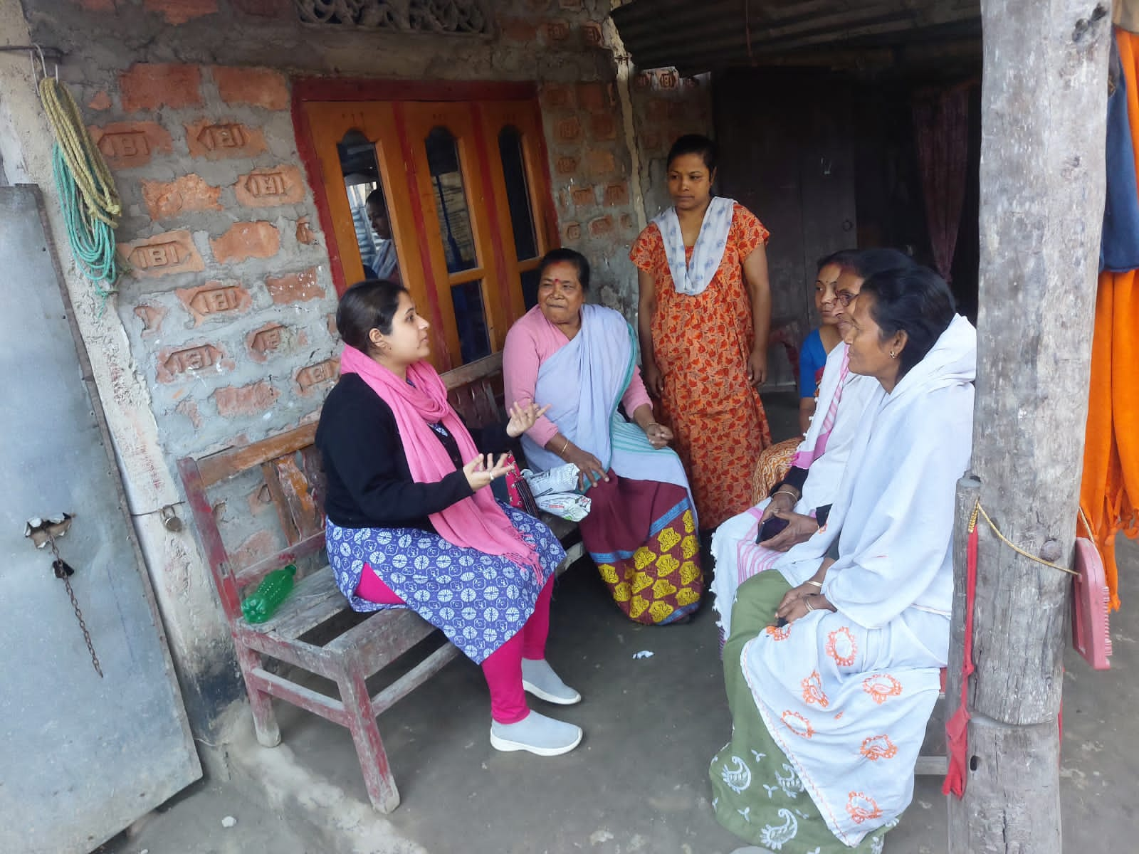After the community meetings and before implementing the CLNOB exercise, the staff carried out Door-to-Door visits in their selected villages. The staff visited individual households and had discussions with household members, particularly the women, about the usual source of water at the household, the quality of drinking water at the usual source, household-level management of wastewater etc. The purposes of these visits were to invite household members to participate in the CLNOB exercise, to develop a basic understanding of the issues around drinking water and greywater management in the villages, and to get familiarized with the socio-cultural contexts of the villages.

Image 4: Door-to-Door visits in Kamrup rural

## Implemention of the Community Leave No One Behind (CLNOB) exercise

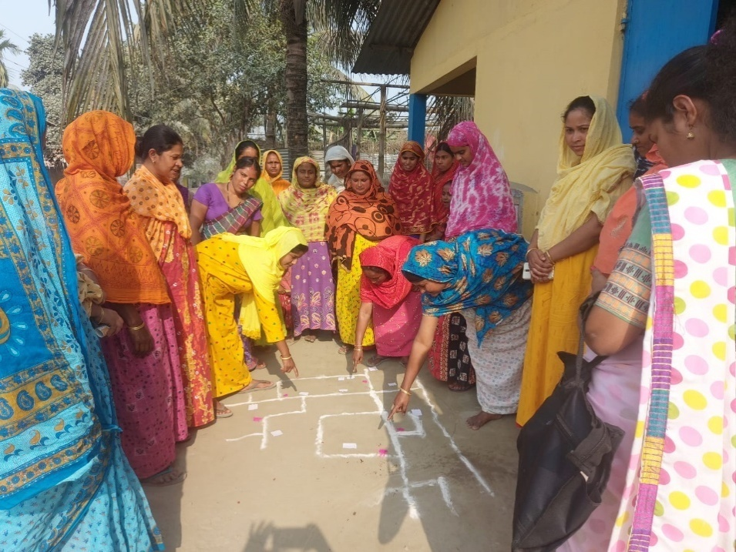Community-Leave No One Behind (CLNOB) is a participatory approach for community-led analysis of a theme of social importance - to understand its status, challenges, and solutions. CLNOB is built upon the experiences of Community Led Total Sanitation (CLTS) and Community Approaches to Sanitation (CAS). The CLNOB approach follows the guiding principle of Leave No One Behind and encourages the communities to analyze the problem statement together for collective planning and actions.

Image 5: Women in Niz Gandmow village participating in CLNOB exercise

In the context of this project, the CLNOB exercise is implemented for community-led analysis of sources of drinking water, greywater management, and sanitation facilities. As mentioned above, UNOPS CDCs planned and scheduled the CLNOB exercise in consultation with the community members in selected villages, and carried out household visits to invite people to participate in the activity. During the exercise, the people of the village gathered at a prominent location. The staff initiated the exercise with group interaction on issues of water in the village and then explained the CLNOB exercise. The people were invited to draw a map of the village on the ground using coloured powders. The people in the village marked all the houses and community places on the map. Following this, all the households on the map were marked with specific details, such as types of water sources, availability of greywater management facilities, types of sanitation facilities, and households with persons with special needs etc. The map was later copied to a chart paper.

### Inter Personal Communication (IPC) Through Post-CLNOB household visits

After the CLNOB exercise was conducted, staff made follow-up household visits in the villages where the CLNOB exercise was carried out. The purpose of these visits was to verify the household-level findings of the CLNOB exercise. Household-specific information such as the drinking water source, the toilet's condition, and the greywater management provisions were physically verified at the household level.

***Outcome:***

* Household-specific findings of the CLNOB exercise are verified and updated.
* Household members were spoken about safely managing greywater and protecting the usual water source.
* Households were informed about the JJM and its importance. Households were further motivated to use piped water under the JJM exclusively.
* Household members agreed to take self-initiation/self-manageable measures to ensure household provisions for safely managing greywater, retrofitting the toilet, water conservation, and ensuring water safety by using piped water under the JJM.

### Social Media Campaign to commemorate JJM's impact on women's lives

* To celebrate international women's day this year, organization has launched a social media campaign highlighting the positive changes JJM brought to women's lives.
* In this regard, two short videos have been recorded in the project village in both Nalbari and Kamrup rural districts. In these videos, the women beneficiaries spoke about the hardship they experienced before JJM was introduced with water accessibility and quality; and then narrated how JJM positively changed their lives and the quality of their lives.
* Both the videos from Kamrup rural and Nalbari are uploaded on UNOPS social media pages on Facebook and Twitter.

**Project-3 :** **Provision of capacity building management and support for the implementation of Jal Jeevan Mission (Rural Water Supply Program): Assam**

Before initiating activities in the field IDS has advertized the post to be filled for Rajasthan project, conducted interview, selected candidates and organized 5 days training for the newly recruited staff. Once the staff based in the field following activities were conducted.

1. **INTRODUCTION WITH LINE DEPARTMENT IN STATE AND DISTRICTS**

## After the staff training organized in New Delhi in the month of December, the Rajasthan team, introduced themselves with the officers of the line departments at the state and district level and informed about the activities of organization being carried out in the state.

1. **MEETING OF UNOPS NATIONAL TEAM WITH STATE PHED OFFICILALS**

A meeting was held with the Additional Chief Secretary, Public Health Engineering Department, Rajasthan on 15th December. In this meeting the model villages to be built in Rajasthan were discussed. Discussion was also held for the sitting arrangements of the personnel working in the project. Apart from this UNOPS will support training and capacity building, case study, I.E.C. material development and making of Video Documentary.

1. **SELECTION OF VILLAGE**

Rajasthan team discussed with Superintending Engineers, Executive Engineers,Assistant Engineers, DPMU and ISA regarding selection of 50 villages in Jaipur(Gramin), Alwar, Jodhpur, Ajmer and Udaipur with the help of available data on the website of Jal Jeevan Mission was 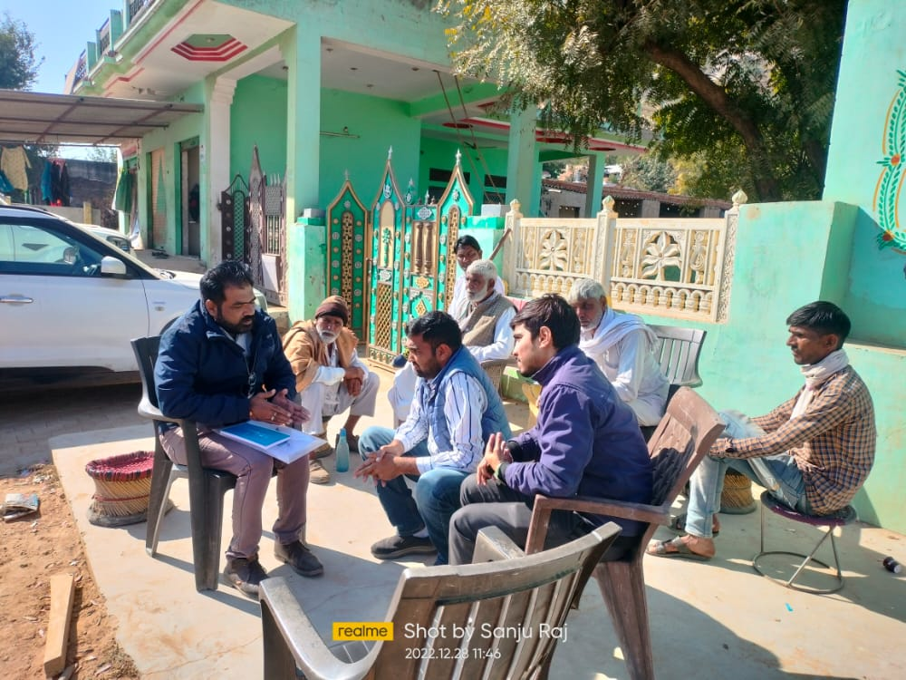used. Firstly, potential blocks were identified by Community district consultant of each district. Based on the list of villages compiled, finally 10 villages were selected from each district after observing the villages. Under the Jal Jeevan Mission, priority was given to the villages where minimum activities were organized, active sarpanches were present and should have minimum distance from block and district headquarters and should not fall under Semi/Peri Urban Category. For selection of villages, total 10 blocks were observed and 70 villages were selected at primary level. Out of which 50 villages were finally selected. All these 50 villages are located in total 30 gram panchayats. During village selection we used a template regarding selection of village and this template was used to collect data by our CDC(s).

1. **CLNOB exercise in villages :**

In the identified model villages of Rajasthan, dialogue was first established with the villagers through CLNOB exercise. Information about the social and economic activities of the village was obtained by discussing with the villagers. Due to this discussion dialogue was established between UNOPS and the villagers. A belief was instilled in the villagers that organization would cooperate in various activities related to the availability of water in their villages through various activities for the next 2 years.

* 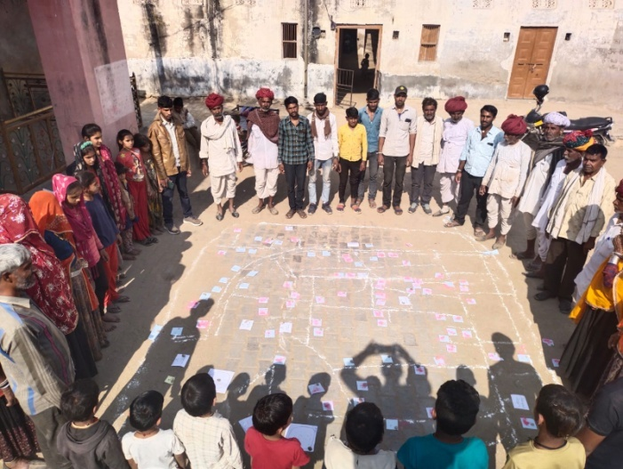During the first phase, the facilitator contacts the villagers and invites them to engage in the exercise on a predetermined date and time at a designated public spot, during which the facilitator gains a general understanding of the village's reality.
* In the second phase, villagers practise CLNOB in a public space with the assistance of a facilitator (where 100 people can gather). Through this, each and every information of the village's periphery, roads, streets, drains, habitations, public buildings, wells, handpumps, well toilets, etc. is collected and marked on the ground. Gulal of different colors (white, blue, red, green, yellow etc.) is used to show the Nazari Naksha and other desired places/points.
* 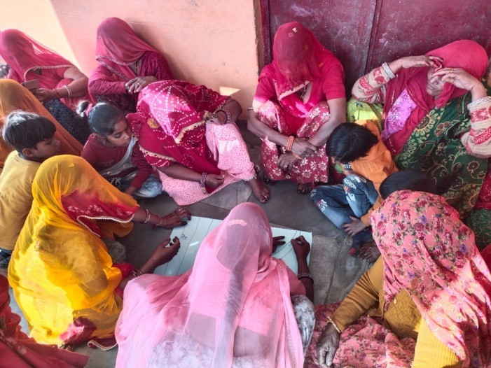In the third phase, the data obtained is confirmed by viewing each house based on the map created and future plan is made on the basis of this. This exercise has been done in 50 identified villages of 5 districts.
* CLNOB is an exercise to be done in collaboration with the villagers, through which information about the current status of water and sanitation in the village is collected through “Nazri Naksha”. On the basis of this, water supply is planned in the village. If the plan already exists, then it can be evaluated. It can also be modified as per the requirement.

In the month of February CLNOB exercise was done in the villages. This exercise has been completed in 27 villages so far in this month.

1. **Compilation of Village Profile:**

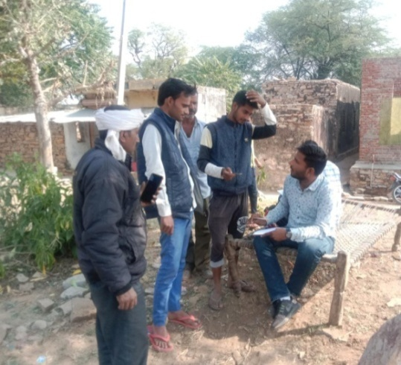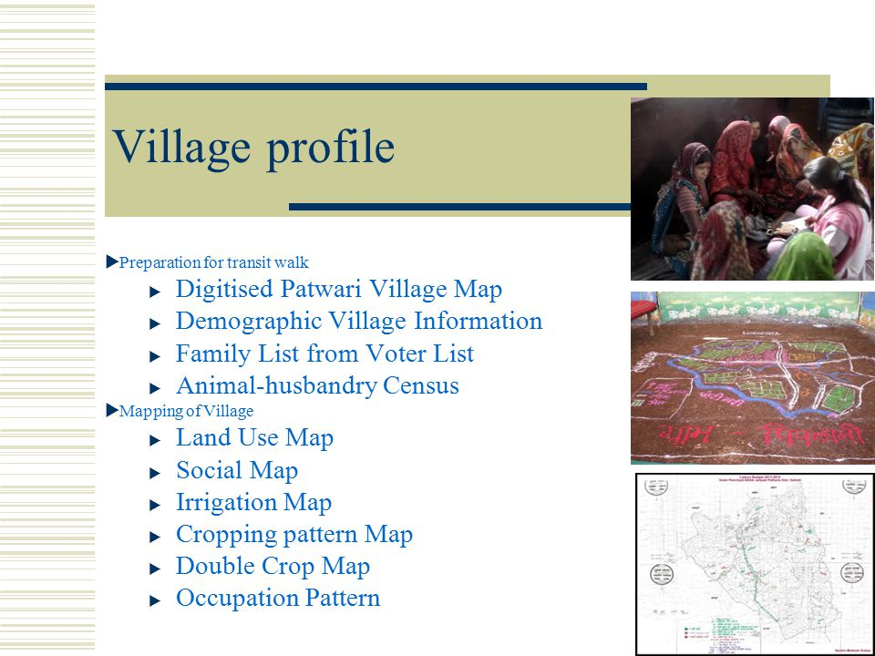Activities for preparation of village profile of model villages were also done during the month of February. The objective of this activity is to collect the basic information of the model village. So that help can be taken in the preparation and modification of Gram Panchayat Development Plan and Village Action Plan. In addition to the basic information of the village, prepared on the basis of 42 points, information about the location of the village water and sanitation committee, their training, their technical knowledge, women's participation, status of tap connection, implementation partner agency and their activities, etc. compiled through the form. The work of information gathering has been done by the District Counselors in the Gram Panchayat with the help of the Village Development Officers with the help of local I,S,A.

1. **Door-to-Door visits for data validation :**

An important process is to verify the data received after the CLNOB exercise. Therefore, on the next day of the exercise, physical verification of the data obtained is done by the staff and some enthusiastic volunteers or young students from that village. During the house-to-house contact, a conducive atmosphere is created when the staff interacts with the head of the household, giving them a sense that the contact is going to last for the next 2 years. During this, all the houses were visited and information was obtained about the members of the house, especially the women, the elderly, as well as the source of water in the house, the quality of water, the household level management of waste water, and the condition of the toilet.

**PROJECT4: GIRL CHILD EDUCATION PROGRAM**

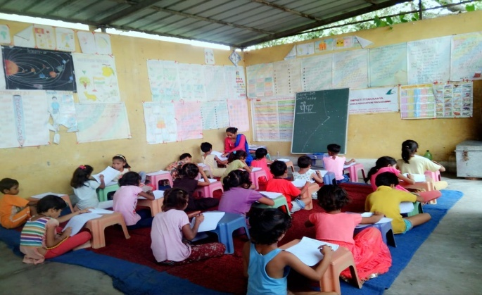Institute for Development Support with the partnership of IIMPACT is continuously facilitating Girls Child Education Program in the districts i.e. Dehradun and Uttarkashi district. The program provides free quality educational opportunity to girls aged 6-14 years from socially and economically disadvantaged community of selected area. The objectives of the program are (a) provide meaningful and stimulating education to girls and guide their entry into formal schooling (b) empower and mobilize girls child to become active change agent in their community by helping change society and mind sets around them.

The key activities conducted during the year under the program are described below.

**Operation of the Learning Centers**

The learning centers are community based located closed to girl's home to facilitate access and to deal with potential parental concerns. The presence of the female teachers also helps them overcome their inhibitions. Each and every center is being operated for 4-5 hours per day. The continuous involvement of the parents in the management of the centers eventually gives total ownership of primary education to the local community which helps in the retention of the girls facilitating continuous learning.

The education model ensures that there is flexibility and adaptability of pace of teaching, teaching methodology, school time table, etc., that suits every out of school girl and no such girl is left out of the program in the project area/villages. The numbers of operational learning centers in both the state are given below.

|  |  |  |  |
| --- | --- | --- | --- |
| **S.N.** | **Name of district** | **No of Learning Center** | **No of Girl child** |
| 1 | Dehradun | 51 | 1530 |
| 2 | Uttarkashi | 58 | 1740 |
|  |  | **109** | **3270** |

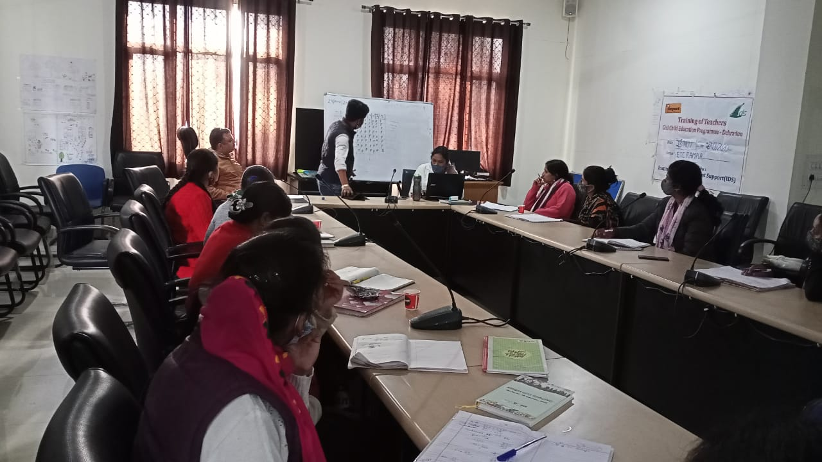**Training of Teachers**

Teachers are the key to meaningful learning and education selected from local villages itself after well laid down process. An education system succeeds or fails due to quality of its teacher. Therefore, valuing and investment in teachers is a necessity. IDS has conducted quarterly teachers training workshops seeking to improve teacher's subjective knowledge and innovation in teaching skills. The teachers are also trained is issues like health, hygiene, nutrition, and environmental sanitation including preparation of learning material. The no of trainings conducted is given below.

|  |  |  |  |
| --- | --- | --- | --- |
| **S.N.** | **Name of district** | **No of Training** | **No of participants** |
| 1 | Dehradun | 8 | 224 |
| 2 | Uttarkashi | 8 | 260 |
|  |  | **16** | **484** |

**Community mobilization and meeting**

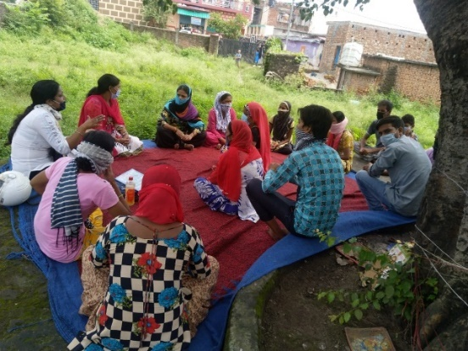Center Management Committee (CMC) is organized by IDS for the management of each and every learning center. The parents and members of village community are the members of the committee. Interaction meeting with the larger community members is a regular activity to ensure participation in educating girls. The main aim of the meetings is to discuss the academic progress of the children as also attendance issues with the parents. Parents are also provided orientation on various aspects of their children's development. Apart from academic discussion, issues related to child protection, health, nutrition are also discussed so that they can guide their children properly at home to lead a healthy life. The CMC also provides infrastructural support to operate the learning center. The no of CMC meeting are conducted is given below.

|  |  |  |  |
| --- | --- | --- | --- |
| **S.N.** | **Name of district** | **No of meeting** | **No of participants** |
| 1 | Dehradun | 204 | 3876 |
| 2 | Uttarkashi | 232 | 4640 |
|  |  | **436** | **8520** |

**Reading Campaign**

Reading Campaign has been initiated to promote the culture of reading in communities and drawing inspiration from the Government of India’s Padhe Bharat initiative, IDS started its own 100 Days Reading Campaign in all the Learning Centres starting from January 2022. The whole campaign had been designed in a way that it would help to not only develop reading habits but also help students in exploring their creativity and imagination. Through this campaign students created their own stories and their own libraries, which gave them a lot of confidence. The campaign was implemented all across the centres.