Annual Report 2021-22

Institute for Development Support (IDS)

Annual Report 2021-22

A BRIEF PROFILE OF INSTITUTE FOR DEVELOPMENT SUPPORT
Institute for Development Support (I.D.S) is a registered autonomous non-governmental organization, established in 1993-94 and based in Pauri Garhwal, Uttarakahnd. IDS works with rural, urban communities of the Himalayan region with the prime motto of empowerment of the society. The organization believes in an integrated development of Man and Nature and actively involves the stakeholders in implementation of innovative programs in the rural, urban areas of Uttarakhand. IDS mantra is to facilitate mountain communities to know and understand their own strength so that they could participate in the developmental and environmental activities. The organization aims at helping people utilize their inherent potential to improve their well-being through self awareness and use of traditional wisdom. IDS has multidisciplinary team of professionals including development planners, extension workers and trainers having many years of experience in project development, implementation, capacity building, monitoring and evaluation.

Vision of the organization
To create an empowered and self reliant society

Mission of the organization
To develop and implement innovative, multidisciplinary developmental programs that are sustainable and replicable.
Objectives of the organization
- To improve socio-economic status of the society.
- To Implement integrated rural development programs for the sustainable development of the society
- To organize capacity building programs for the enhancement of knowledge, skill and entrepreneurship development.
- To create awareness and plan, implement, monitor and evaluate programs related to Education, health, Livelihood, and environment rehabilitation
- To build capacity of community based organization, women groups and panchayati raj institutions in natural resource management.
- To implement awareness programs for the eradication of various social evils prevailing in the society.
- To introduce various appropriate technologies such as rain water harvesting, biogas, solar energy, composting, solid, liquid waste management, pasture and fodder development, soil-water conservation etc.
- Publication and production of books, magazines, newsletters, posters, films, audios and videos.
Partners
- United Nations office for Project Services (ORGANIZATION)
- Water Supply and Sanitation Collaborative Council, an UN unit
- UNIDO (United nation Industrial Development Organization, Vienna, Austria )
- Integrated Livelihood Support Program-IFAD, Govt of Uttarakhand
- Uttarakhand Tourism Development Board, Govt of Uttarakhand
- WISIONS,Wuppertal Institute for Climate, Environment and Energy, Germany
- IIMPACT, Gurugram Haryana.
- Indo German Energy Program, GIZ, New Delhi
- National Bank for Agriculture and Rural Development (NABARD)
- Forest Department, Government of Uttarakhand
- Jal Sansthan and Jal Nigam, Government of Uttarakhand
- District Administration, Pauri Garhwal
- Health Department, Government of Uttarakhand
- Sir Ratan Tata Trust (SRTT), Mumbai
- District Project Management Unit (DPMU), SWAJAL, Department of Drinking Water, Government of Uttarakhand
- Uttarakhand Renewable Energy Development Agency (UREDA), Government of Uttarakhand
- Shri BhuvneshwariMahila Ashram/ PLAN International
- World Vision, Pauri Garhwal
- Department of Science and Technology, Govt. of India
- Indian Institute of Technology, Roorkee
- CDM Smith Associates Inc. Banglore.
- HIFEED, Ranichounri, Tehri Garhwal
- M/S Karvy Pvt Ltd
- Centre for Environmental Education, Lucknow
- IT Power synergy services Ltd, Gurgoan
- Department of Planning and Statistics, GoUK
- IL&FS Pvt. Limited, New Delhi

Institute for Development Support is working in more than 200 villages of 12 districts of Uttarakhand and slum area of Delhi in the following areas.
- Economic Empowerment: The program is focused to promote agriculture & horticulture based livelihood of the local community, training, capacity building, and vocational training to youths on different livelihood options. In addition to this the program is also focused to establish the community based micro finance groups or women SHGs engaged in micro enterprises for their livelihood enhancement. Many trainings and capacity building programs were organized in vegetable farming, bee keeping, dairy development, spices cultivation, mushroom farming, fruit processing, nursery development, poultry, marketing of the products and non farm activities such as re-cycling of waste material and development of products in rural and urban areas.
- Community Based Tourism:IDS has been engaged in planning, implementation, monitoring and supervision of community based tourism activities in 12 districts of Uttarakhand for livelihood enhancement. The key activities being performed under the projects are identification of suitable villages for tourism development, IEC, formation and management of village tourism development committee, eco development committee, identification of their training need, designining and implementation of training in hospitability management, cooking, bird watching, interpretation, nature guiding, low cost dwelling units, business plan preparation, linkages with parytanswarojgaryojna and established linkages with marketing agencies.
- Water & Environment Sanitation: IDS has facilitated planning and implementation of many rural water and environmental sanitation schemes in the villages of Uttarakhand supported under Sector Wide Approach and total sanitation campaign. IDS empowered community based organization particularly village water and sanitation committees to execute safe water supply and sanitation program for sustainable health and hygiene. An innovative, solar lifting water scheme was also constructed to fulfill the need and demand of the villagers. Apart from this, IDS is facilitating construction of household sanitary toilets, school sanitation and environmental sanitation.
- Gender Empowerment: Under this program, the organization is generating awareness among community members, PRIs, women groups, government officials/institutions, children groups on gender equity and equality. Capacity building training of youth & women on different issues/skills, government law & policies are also the part of the program.
- Renewable energy for livelihood development: Organization is engaged in implementation of programs that promote clean, green renewable energy to mitigate the adverse impact of climate change. To generate awareness among community members about green energy, IDS has organized several Green techno fairs or exhibition in Uttarakhand. Traditionally watermills have been source of clean energy and mechanical power to grind food grains in Uttarakhand. IDS has also been engaged in installation of model water mill and improvement of traditional water mill for electricity generation as well. The local communities residing nearby the watermill were organized into SHGs for the processing, packaging marketing of watermill processed products for livelihood enhancement.
- Education & Health Program: IDS is regularly involved into improvement in formal and informal education program with communities. Organization operating 130 Education Center for the girl child who could not attended formal schooling or drop out from the school in Dehradun and Himachal. Apart from this IDS also promoted eco clubs in the 150 school for imparting better environmental education to children. Child right is another key area where organization has organized many advocacy programs. IDS implemented reproductive child health program that include preparation of birth plans, educating & mobilizing mothers for early registration, complete vaccination, IFA distribution, institution delivery and other health & hygiene issues. In addition to this the program is also focused to educate adolescents on reproductive & sexual health, conduction of health camps in remote area, regular school level camps, regular counseling, eradication of female foeticide and treatment of mal-nourished children etc.
- Natural Resource management
The economy of Uttarakhand is more dependent on natural resources. The condition of the natural resources is deteriorating day by day. Considering the facts, IDS have been regularly engaged in conservation and protection of natural resource through community institution such as van panchayats, PRI, SHGs and Mahila Mangal Dals. The key program organized under the components are formation and strengthening of van panchayats, imparted different capacity building trainings to committee members and villagers, supported to committee members for nursery development, plantation, trenching, construction of ponds and rain water harvesting tanks.
Management structure
The executive board of the IDS is apex body which provides guidance and takes final decision regarding growth of the institution. The Executive Director nominated by the apex body is responsible for the implementation of the decision taken by the board. Executive Director provides guidance and assistance to staff, project team and field facilitator for effective planning and implementation of the programs. IDS has separate Project Coordinator or Team Leader and experts for the projects being implemented by the IDS.
Executive Body
Executive Director
Program Coordinator

Program Coordinator
Program Coordinator

Field Facilitators

Field Facilitators

Field Facilitators

Admin &Finance Officer

Subject specialist

Summary of projects Activities carried out by Institute for Development Support during 2021-22

S.N. | Project name/ Place | Beneficiary | Funding from
1 | Provision of capacity building management and support for the implementation of Jal Jeevan Mission (Rural Water Supply Program): Uttar Pradesh_Phase-I | Rural community of UP | United Nations Office for Project Services (ORGANIZATION)
3 | Girls Child EducationProgram | 35 villages of Dehradun and 45 villages of Mori block of Uttarkashi | IIMPACT, Gurugram, Haryana

PROJECT-1 Provision of capacity building management and support for the implementation of Jal Jeevan Mission (Rural Water Supply Program): Uttar Pradesh_Phase-I
Jal Jeevan Mission (JJM), announced by the Hon’ble Prime Minister Modi on 15th August 2019 from the ramparts of the Red Fort, has brought water to the centre of the development agenda and action. The Jal Jeevan Mission (JJM) aims at providing Functional Household Tap Connection (FHTC) to every rural household by 2024 through piped water supply. The Prime Minister has appealed to make it a ‘Jan Andolan’ (mass movement). It was proposed to achieve the goal by 2024, coinciding with the UNSDG- 6.
As a sector partner of the Government of India, UNOPS is offering strategic-technical assistance and capacity building support to the Jal Jeevan Mission in 137 villages of 11 districts (Prayagraj, Kaushambi, Mirzapur, Sonbhadra, Chitrakoot, Banda, Mahoba, Hamirpur, Jalaun, Jhansi and Lalitpur) of Uttar Pradesh, India. UNOPS is committed to create 100 model gram panchayats under JJM in these districts. Gram Panchayats shall be selected in consultation with District and state Government. The key support areas shall include capacity building; institutional strengthening; operation and maintenance of systems; financial sustainability of systems; sustainability of water resources; community-based water quality monitoring and surveillance; Rapid Action Learning; studies, research and knowledge management; and preparation and submission of village action plan.
To achieve the objectives of strategic/technical support extended to GoI, UNOPS selected IDS as a grantee is providing technical support through recruitment of quality human resource and overall management of activities designed for successful implementation.
2. PURPOSE
I. To provide technical support to UNOPS for conduct of activities of Jal Jeevan Mission (JJM) as per national guidelines
- The grant budget is initially for a period of one year.

- SCOPE OF WORK

The organisation is implementing following activities in close consultation with Head WASH, UNOPS
• Deploy experts/consultants, as needs arise, for the performance and fulfilment of tasks related to Jal Jeevan Mission including but are not limited to Engineering, Technical, Advisory, Finance, Human Resources, Logistics, Asset, Office and Administrative support, Data Collection, etc.;
• Organize training and workshops as planned in consultation with UNOPS.
• Implementation and overall management of the activities planned in consultation with UNOPS
• Provision of logistic support to WASH unit ORGANIZATION when requested like organisation of advocacy meetings, Jan Choupals, padayatras, puppet shows, films and other such IEC activities;
• Payment of vendors for venue, accommodation, travel, banners, workshop materials, prints and related expenses for organising training and workshops;
• Orientation of staff;
• To organise and conduct National/regional Level Rapid Learning Workshops;
• Awareness and sensitization meetings on JJM with community and NGO functionaries;
• Training and capacity building of community participatory development, institutional strengthening;
• Training and capacity building of Pani Panchayat/VWSC/USER GROUP in community action planning;
• Training and capacity building on operation and maintenance of the schemes;
• Training and capacity building on community-based water quality monitoring and surveillance;
• Training and capacity building on catchment protection and source sustainability;
• Facilitate and organise block and district level orientation meeting with PRIs representatives in all 11 districts;
• Water quality testing of 100% water sources in focused 100 Gram panchayats;
• Identification of five women in each gram panchayat and build their capacity to use field test kit for water quality testing;
• Preparation of Village action plan in consultation with community.
- Demonstration of innovative technology for grey water management
- Organize Rapid Action Learning workshops Under JJM and SBMG-Phase-II

- ORGANIZE AND CONDUCT TRAINING FOR THE RECRUITED STAFF
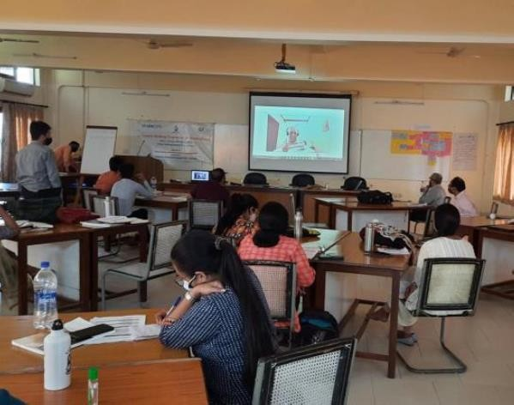
A six days training program was conducted for the staff recruited at national, regional and district level under JJM assignment. Total 20 participants attended training program between 12-17th April 2021 at SahbhagiSiksha Kendra, Lucknow, UP. Apart from this, Head, WASH, Finance and Admin Manger from ORGANIZATION attended and facilitated the training program.
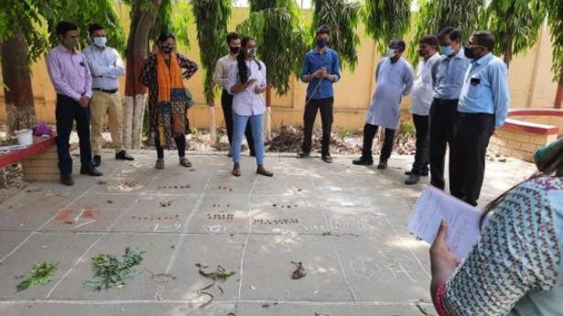
This six-day training on Jal Jeevan Mission was designed as an orientation training workshop. Training is conceived as an interactive exercise in participatory learning, where participants have been involved as resource persons and resource persons as participants. Participants have involved in a series of individual and group activities aimed at promoting
learn by doing. These exercises have facilitated by experienced resource persons ensuring active involvement of the participants with desired gender sensitivity. Focus have been on practical and experiential learning.
The training is aimed at equipping the participants with necessary, knowledge, skills and orientation for facilitating the effective implementation of JJM in the areas/districts of their work. The six-daytrainingwas evenly divided across six submodules of one day each focussed on a selected thematic issue or/and domain. Equal emphasis was given onthe knowledge, skills and orientation components of this participatory learningexercise.
Being a customized training program designed as a onetime event in the midst of the fast-worsening crisis of the second wave of COVID-19 pandemic, as it obtains in April 2021 in India and UP, no field visit is planned due to assembly and mobility restrictions, though it was
originally conceived to be an integral part of this orientation training focused on experiential learning. However, it has been ensured that practical learning takes place through effective group and simulation exercises.
Scope of the training
The scope of training coveredall the aspects of JJM, as available in the JJM Guidelines, issued by DDWS, MJS, GoI. The training schedule presentedthe flow of different training sessions with an overview of key points of content and the duration for each session. The section ofsession briefs provides detailed session plans including the following: session objectives; duration; methods; materials required; process to be followed; tips for trainers/facilitators
Objectives of the Training

At the end of the training, participants were able to have an informed understanding of:
1. The historical background of the rural water sector in India covering ARWSP, NRDWP up to JJM
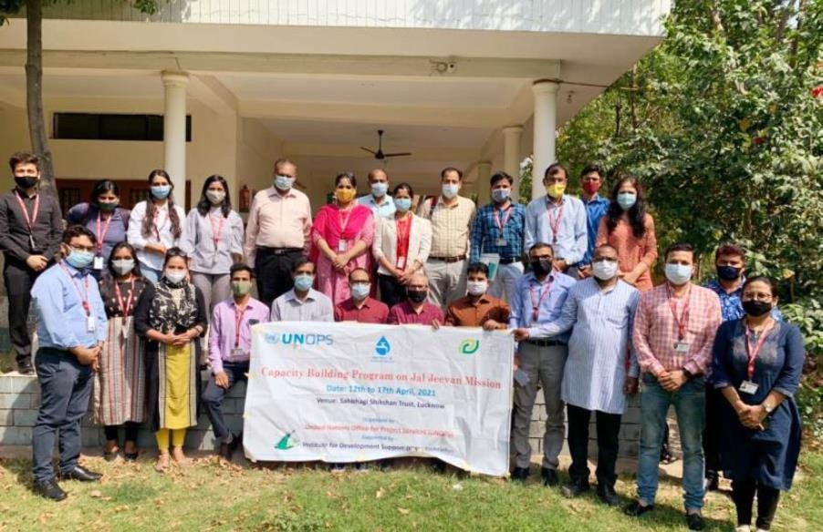
2. JJM vision, mission, strategy, components and the key interventions at HH and community level for JJM.
3. Community approaches to ensuring water security and sustainability at the village level.
4. Participatory approaches such as PRA and PLA for participatory data collection at the community level followed by community analysis and mobilization
5. Planning, design, implementation and operation and maintenance of water supply schemes and systems with focus on operation and maintenance (O&M) planning and monitoring at the
community level
6. Community led approaches such as CLASS and CLNOB and their use on the ground at the community level
7. Appropriate and cost-effective technology options such as solar power-based schemes.
8. Key issues in water security and sustainability including: source sustainability; water conservation; water recharge; grey water management; rainwater harvesting etc.
9. Village Action Plan (VAP) preparation
10. Strategic action planning for the district teams of the WASH Program of ORGANIZATION India

Structure of the Module
This training (48 Hours 30 minutes over 6Days) hadtwo major parts:
- Presentations and discussions: Various issues and dimensions of Jal Jeevan Mission (JJM) including source sustainability, water conservation, water quality monitoring and surveillance, O&M planning, village action planning and community monitoring.
- Group work and simulation xercises:Hands-on experience of participatorydata collection, use of field test kit fortesting the quality of water, and use ofPRA, PLA, CLASS and CLNOB tools.
Training Methods: following methods were adopted for classroom sessions:
- Interactive lecture/ Power-point
- presentations (PPTs)
- Experience sharing
- Group discussions/tasks
- Analytical/simulation exercise
- Screening of selected videos

- COOMUNITY LEAVE NO ONE BEHIND (CLNOB)

The Community Development Consultants in consultation with their respective State Coordinators, embarked on initiating entry into villages through a participatory approach called Community Leave No One Behind (CLNOB). While this exercise, the Community Development Consultants engaged with the community in their respective villages to develop maps, which would indicate the current situation of water supply, grey water management and sanitation in their villages. This data would enable the Community Development Consultants to advise the district administration on a robust and holistic approach to water supply systems in the rural parts which is demand driven and not supply driven.
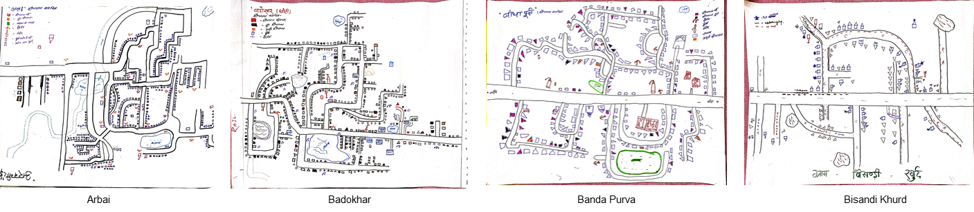

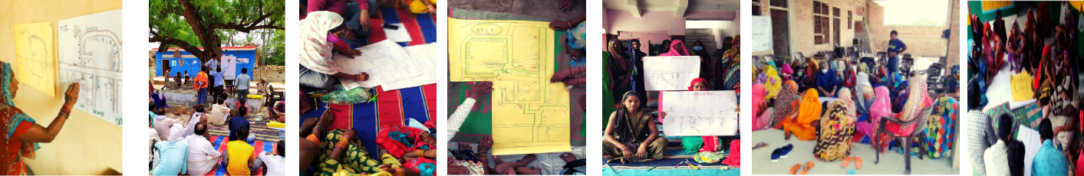

- DISTRICT AND BLOCK LEVEL ORIENTATION WORKSHOPS
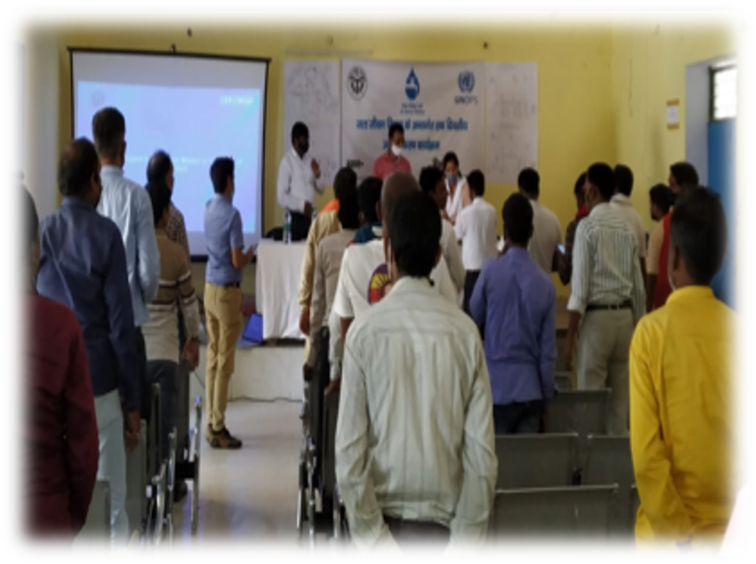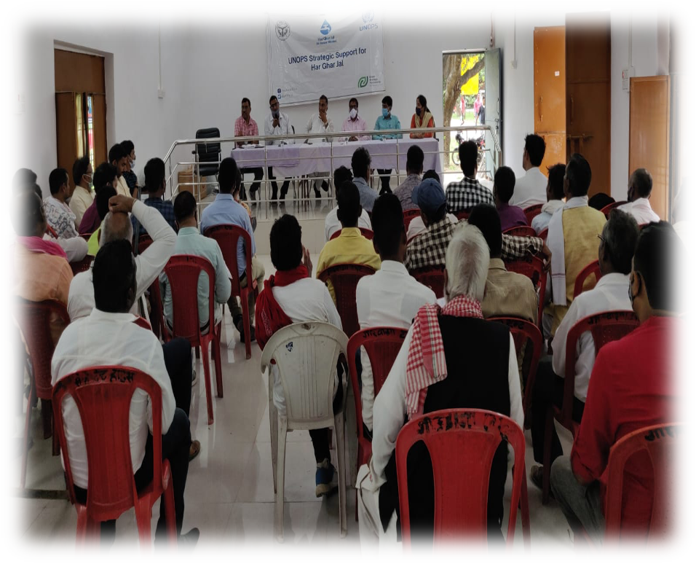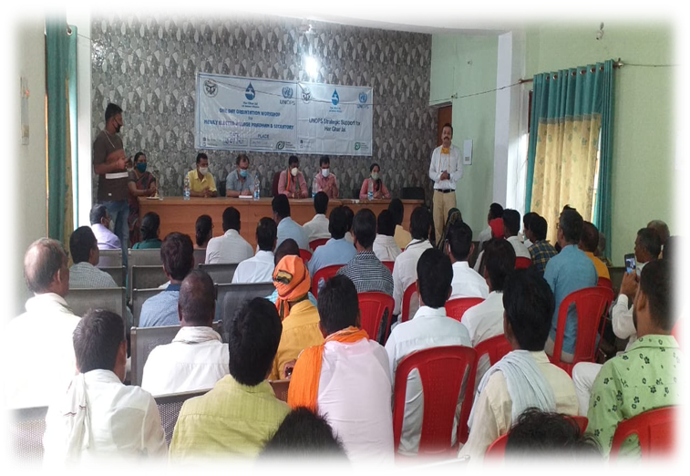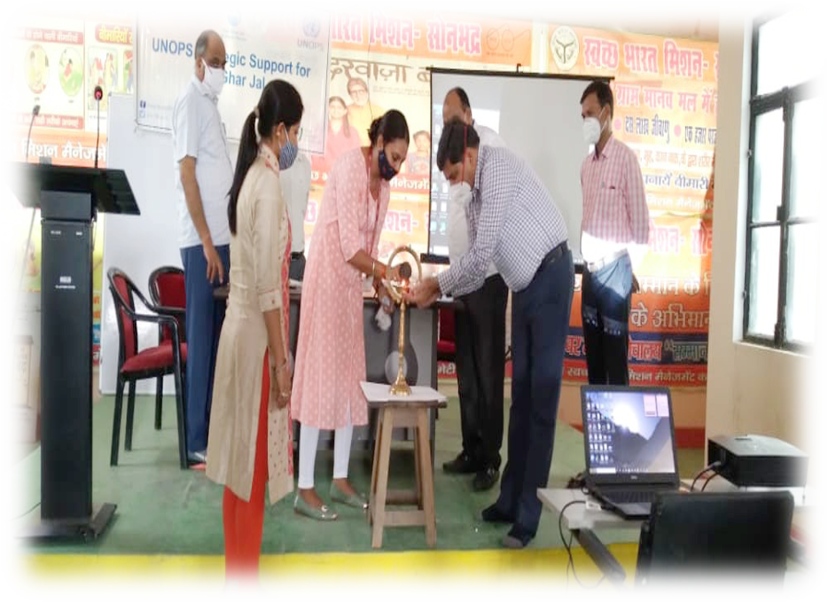The first group of stakeholders that we engaged with were gram pradhans and block development committee members, in each district our intention was to empower these individuals to mobilize political will and support at the village level, Information was provided regarding the flagship program of the Union Government which aims to provide tap water connection to every household of the country by 2024.
The discussion also includes the roles and responsibilities of Pradhan, Secretary, and BDC members in their Panchayats. There were a hundreds of participants, this included Block development committee members from block Kabrai. Junior Engineer Jal Nigam Dheeraj Singh was present in the meeting, the session was moderated by the project team, also present were representatives of a local NGOs that works on encouraging water and sanitation in the districts. The focus was to make the participants understand that the Jal Jeevan Mission is based on a community approach to water creating a jan andolan for water, thereby making it everyone’s priority. Also, providing water to every household is an inescapable duty of any Government.

- WATER QUALITY TRAINING
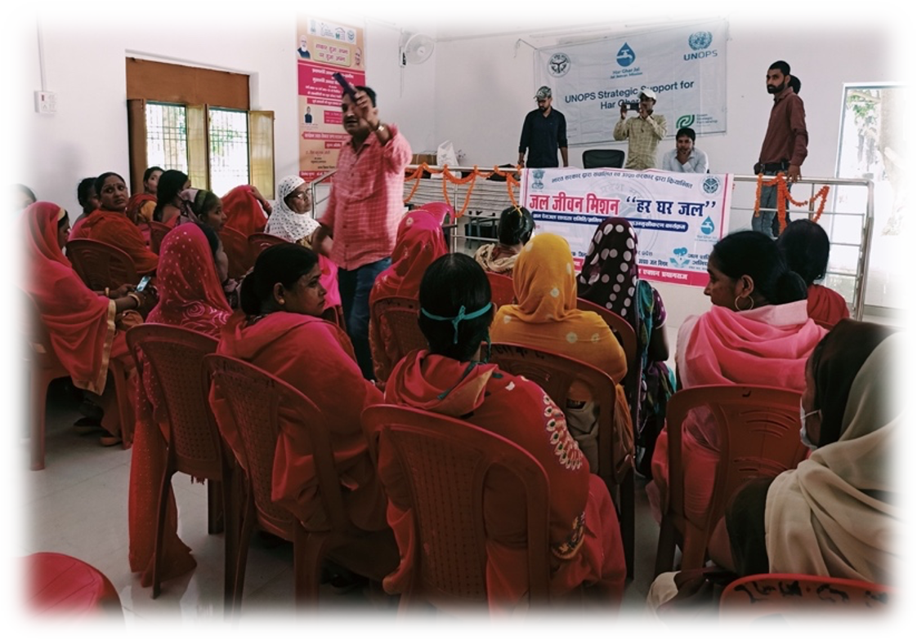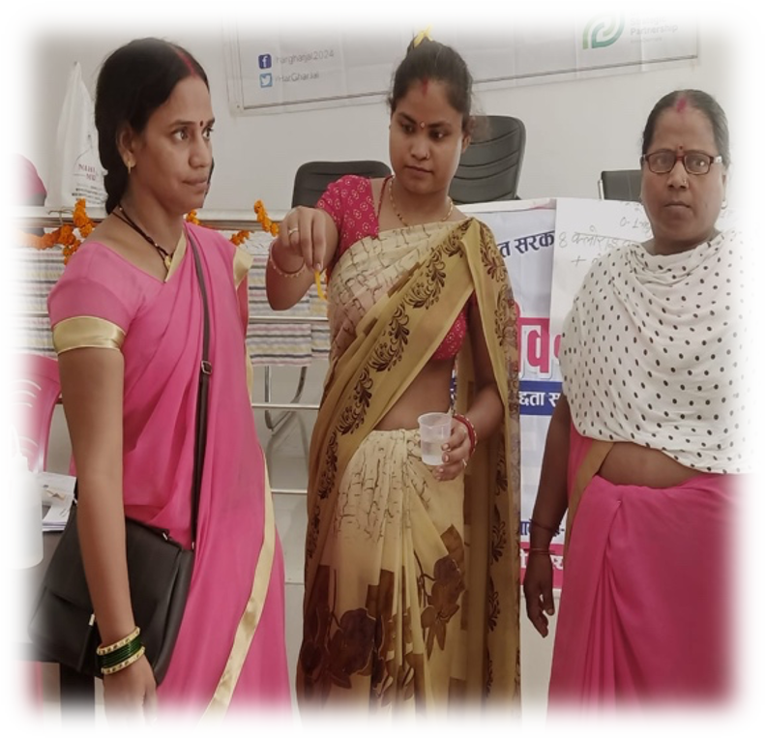The second group of stakeholders that we engaged with was the 5 women that were slected by organization in each district. With these trainings, our hope was to help the women that have been selected to become familiarised and comfortable with operating the Field test Kits being provided to each Gram Panchayat across the district.The objective of this traning was two fold, National Consultant from organization, Tathagata Ghosh, traveled to Banda in order to train the seleted women for water quality in Banda, while the State consultants from organization were also present, and hence it was a training as well as a training of trainers.
The training began with an introduction to the need for water testing, where the various diseases caused by bacteriological and geogenic contamination were discussed briefly. Since the objective of the training was to help demystify the complexity of an FTK and to help the selected women get familiarised with the testing kit, volunteers were invited from the group of attendees and were asked to follow along with the instructions and conduct the tests themselves. As a a cautionary note, the attendees were requested to take sanitary and safety precautions while handling the equipment of the FTK tests kit. They were informed about the protocols that needed to be followed for proper sample collection, like ensuring that the utensil of the sample collection was sanitized, the person who would be handling the samples should sanitize themselves prior to the collection, and that the kit included some harsh chemicals and personal safety was to be maintained at all times, some tips like ensuring that one is always wearing thick plastic gloves while handling the samples, that one should not look directly at the test tube/ while dealing with chemicals always maintain a safe distance between the eyes and the chemicals and to wear goggles if necessary. One by one, the various tests in the testing kit guide were taken up and volunteers would carry out the testing exercise and demonstrate how it was to be done. PH, Turbidity, Hardness,, Flouride, Nitrate, Residual Chlorine, Chloride, Arsenic, Phosphorous, iron, and other tests were demonstrated one by one with various women who came forward and carried out the tests for the audience. The first test that was carried out was the PH tests with the litmus paper and the effect of highly alkaline or highly acidic water on the human body was explained, Turbidity and Hardness were introduced next as tests that act as indicative tests, ie. high levels of turbidity and hardness in the water could be signs of the presence of other impurities in the water, while low turbidity and harness are positive signs and lower chances of their geogenic and chemical contamination. Next the fluoride test was conducted and the serious implications of the high fluoride levels, like degeneration of bones and dental and fluorosis of the bones was discussed. After than tests like Nitrate, Residual Chlorine, Iron, etc were carried out where the source of these chemical contaminants and how they reach our water sources were discussed, as well as ways to address these challenges and what community action, could be taken, should such impurities be discovered in a water sample.
- FORMATION AND STRENGTHENING OF VILLAGE WATER AND SANITATION COMMITTEE (VWSC)
To drive the purpose of greater ownership of the water supply infrastructure being provided to the villages, the Community Development Consultants facilitated the formation of Village Water and Sanitation Committees (VWSC) in the Gram Panchayats. The VWSC is a statutory body of the local government which is authorized to collect taxes and tariffs for water supply and sanitation in the Gram Panchayats and take decisions of operation and maintenance of these infrastructures. IDS formed a total 92 VWSC in the project intervention villages.
- ORGANIZE COMMUNITY LED ACTION FOR SANITARY SURVEILLANCE (CLASS)
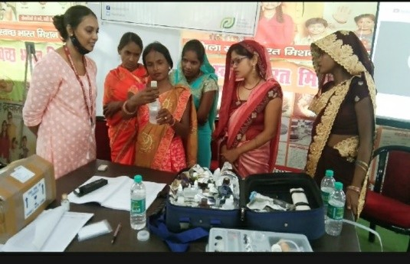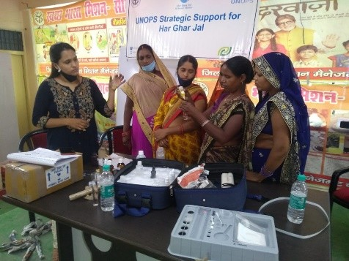The CLASS tool was used to organise water quality tests (WQT) and sanitary surveys in all of the selected villages. The community development consultants (CDCs) aided in the training of women to conduct the WQT, which included a biological, chemical, and sanitary survey of all the communities chosen. A biological and sanitary survey was conducted in all locations. Chemical testing was also carried out at a government school, an Anganwadi, and a nearby supply of drinking water.
- ORGANIZE PANI PANCHAYAT IN VILLAGES
Pani Panchayat could be described as a platform to encourage a dialogue about water security and water sustainability in the community. The sub-activities conducted under Pani Panchayat are as follows:
- Community meeting - An open meeting is called in the village where the facilitator explains to the community what the term Pani Panchayat meant and what all activities could be covered in it. The facilitator makes the community members understand the need to conduct this activity and explains to them its importance. In this meeting one tries to find out the status of water in the village, the status of the sources of water available, the amount of water demand and the actual amount of water received through the various sources.
- Women time use- This activity is conducted to find out how much time a woman spends in the entire day in various task. In this activity the time of women is calculated from the time she wakes up to the time she finally goes to bed.
- Water use analysis – In this we try and find out what are the task that involves use of water and calculate how much water per person is required.
- Source identification – This activity is conducted to find out what are the sources from where the women fetch water for various purposes (cooking, cleaning, washing etc).
Once this data is received, we try analysing how much of woman’s time is saved if they have a tap connection at home.
Process involved
First, we informed the villagers about conducting a meeting with regards to water in the village. We educate them about the activity and tell them in detail what we are going to ask them. We candidly inform them that this activity would require 2-3 hours and in consultation with the villagers book a day and time for conducting the activity.
We meet them on the decided day and begin the activity. The questions that we ask them are as follows:
- We asked them what all work they do from waking up till going to bed.
- Next, we asked them how much time is invested in the work they mentioned
- We ask how much water is required and invested in the work they mentioned. By this we come to know how much water is required by them for cleaning purpose or washing and cooking.
Post this we do a water source mapping and take data as how much water is used from which source and which source is used for drinking, washing and other purposes.
Thus we see that majorly there were two major components of this activity- both centered around the aspect of budgeting- one was women's time use analysis- this activity was facilitated to help women chart their day to day activities and the corresponding time invested to do the same; the second activity was conducted in a gender-mixed group and was intended to be a water budgeting exercise, the end goal was to leave the community with prompts on how grave the water crisis can be-and measures that can be adopted to overcome the same.
The people who were a part of this exercise were mostly women from the village, VWSC member, ASHA, AWC, SHG members and PRI members.
In all the eleven districts, the pani panchayat activities/ water budgeting activities were carried out duly, the reports for the same have also been submitted duly.
In district Jalaun, an event was organized in coordination with the Panchayat in the primary school, Kadaura block of the district, an exhibition was put up that helped us showcase our work to the public. We took the opportunity to display symbols and results from our various interventions, eg, the CLNOB maps, water testing kits and relevant data from our CLASS exercises. Women from the water testing committee were present at the event and were able to successfully carry out the water testing exercise in front of all the people.
In other districts also similar activities were planned and open meetings were held to conduct the Pani Panchayat activities.
The activities under Pani-panchayat
- Participatory Water Use Analysis
- Participatory Women time Use Analysis
- Source Sustainability, Ground Water Management Recharge, Reuse and Convergence Plan
- Rainwater Harvesting Plan
- Coverage of all Households with toilets Plan
- Solid Liquid Waste Management, Segregation of Plastic (Convergence with Gobardhan) Plan
- Grey Water Management Plan
- Community Contribution Plan
- Operation and Maintenance Plan

- PREPARATION OF VILLAGE ACTION PANS (VAPS)
Background and Introduction
To provide FHTCs to all rural households, in-village water supply infrastructure will be created through Single Village Scheme (SVS)/ Multi Village Scheme (MVS)/ solar power-based stand-alone schemes for scattered areas. The Gram Panchayat and/ or its subcommittee, i.e. VWSC/ Paani Samiti/ User Group, etc. will be responsible to plan, implement, manage, operate and maintain in-village water supply infrastructure and water resources including greywater management to meet drinking and domestic needs. It will include protection of drinking water source(s) as well as treatment and reuse of greywater.
For every Village, Village Action Plan (VAP) for providing FHTCs to all households will include cost estimates, implementation schedule, O&M arrangement, contribution from each household towards partial capital cost and O&M, type design of ESR/ sumps, washing and bathing complex with a toilet for poor landless families, cattle trough, greywater management, source sustainability measures, plan to maintain all water bodies in village, etc. The VAP will plan for piped water supply in scattered settlements as per the requirement. The VAP under JJM will be integrated with Gram Panchayat Development Plan (GPDP).
Objective
Village Action Plan intended to help villages design their own plans to assist development in their area. It aimed at strengthening and augmenting drinking water sources in the area. To achieve drinking water security, the Village Action Plan under JJM can be taken up in convergence with other schemes at the village level including MGNREGS, said Minister of State for Jal Shakti Prahlad Singh Patel in a written reply in the Lok Sabha. The 15thFinance Commission has tied grants to Rural Local Bodies (RLBs), Integrated Watershed Management Programme (IWMP), State schemes, District Mineral Development Fund, CSR funds, and community contribution and this could also be used for ensuring water security.
Process involved
An open meeting was organized by the Community Development consultant in the villages taken up by us. The meeting was moderated by CDC in their respective villages. Through this meeting we explained to the villagers that Village Action Plan (VAP) was to be prepared based on the type of scheme taken up in the village to provide FHTC to every rural household. We explained to them that it is also about tap connection to schools, anganwadicentres, GP buildings, health centers, SHG buildings and other community buildings in rural areas.
We educated them that VAP will be the main document of the village for all water supply related works, and on its approval by Gram Sabha all funds from different sources will be dovetailed to implement various components of VAP.
A draft plan was prepared first and then was shared with the community. Any changes they wanted to make in the VAPs were made then. Final VAP was shared in the community through Gram Sabha only. Once finalized and everyone agreed the final VAP was printed and shared with the Pradhan and the District for further actions.
We also had to reach out to various line departments for collecting the data related to rainfall, agriculture, water supply, animal, population, health, irrigation etc.

REGIONAL RAL WORKSHOPS ON ODF PLUS AND JJM

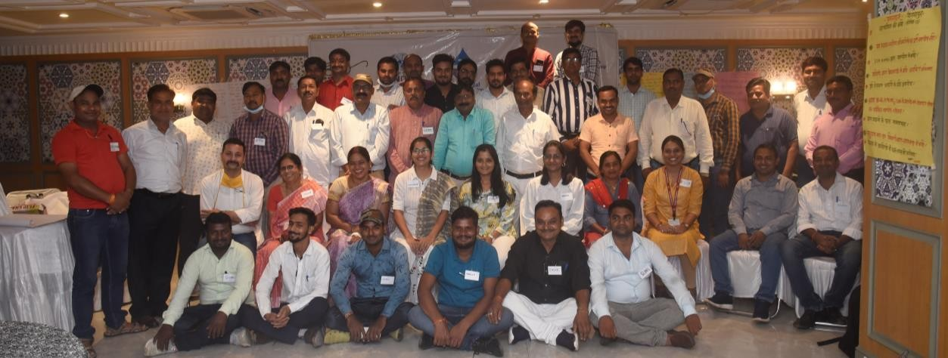
As per the request of Department of Drinking water and Sanitation at Ministry of Jal Shakti (Government of India)in place of 04 sub-national level 3 days’ workshops, WSSCC has produced avideo on “Good practices/Innovation” (under ODF Plus and JJM) in 2020 https://youtu.be/y2f0DAUKOjk). The video was broadcasted on all national channels, and it helped to reach the message of safe water.

The RAL was conducted in Aug 2021, the timelines for these RAL’s were as below
- Prayagraj – Aug 24 to 25 2021
- Chitrakoot -Aug 27 to 28 2021
- Jhansi – Aug 27 to 28 2021

The workshop was held with the goal of sharing and learning about how to carry out the Jal Jeevan Mission in a quality and sustainable manner. The workshop focused on JJM and SBM-G Phase-II approaches, methods, and innovations that have been developed and are being used or tested. UNOPS and Sanitation Learning Hub at The Institute of Development Studies (IDS) at the University of Sussex, UK organised this event. The purpose of the workshop is for participants to share and learn. Obstacles, problems, and lessons learned from what hasn't worked, as well as what is promising or successful, are all vital for learning. The session was attended by Executive Engineers, BDOs, ADOs, Team Leaders of Implementing Support Agencies, and CDCs from all the districts

PROJECT 2: GIRL CHILD EDUCATION PROGRAM

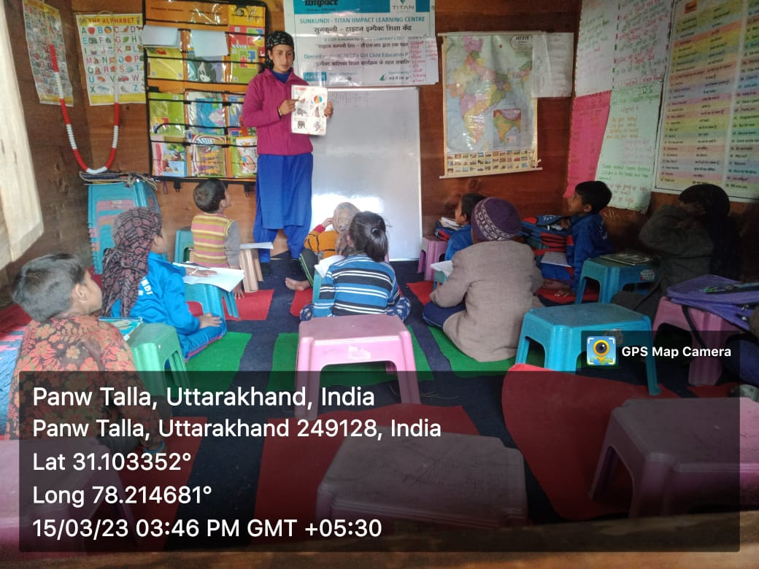
Institute for Development Support with the partnership of IIMPACT is continuously facilitating Girls Child Education Program in the two districts i.e. Dehradun and Uttarkashi district. The program provides free quality educational opportunity to girls aged 6-14 years from socially and economically disadvantaged community of selected area. The objectives of the program are (a) provide meaningful and stimulating education to girls and guide their entry into formal schooling (b) empower and mobilize girls child to become active change agent in their community by helping change society and mind sets around them.

The key activities conducted during the year under the program are described below.

Operation of the Learning Centers
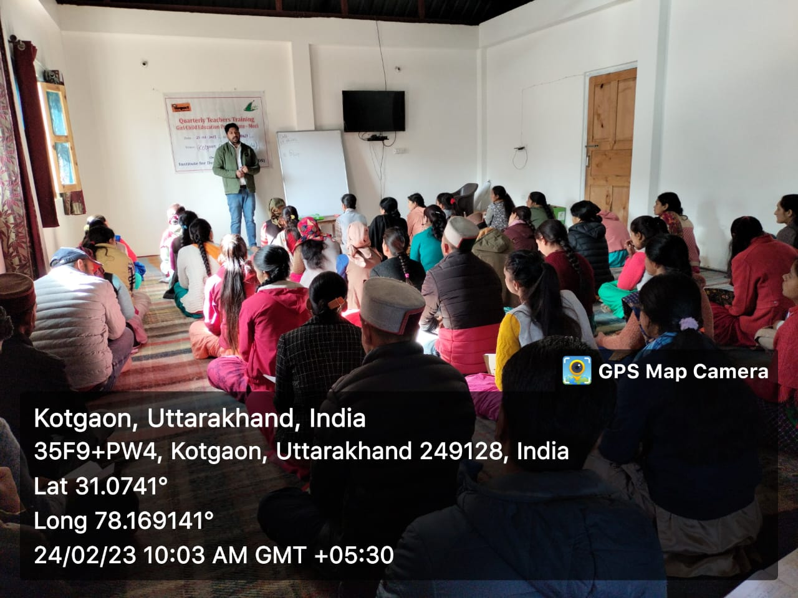
The learning centers are community based located closed to girl's home to facilitate access and to deal with potential parental concerns. The presence of the female teachers also helps them overcome their inhibitions. Each and every center is being operated for 4-5 hours per day. The continuous involvement of the parents in the management of the centers eventually gives total ownership of primary education to the local community which helps in the retention of the girls facilitating continuous learning.

The education model ensures that there is flexibility and adaptability of pace of teaching, teaching methodology, school time table, etc., that suits every out of school girl and no such girl is left out of the program in the project area/villages. The numbers of operational learning centers in both the state are given below.

S.N. | Name of district | No of Learning Center | No of Girl child
1 | Dehradun | 51 | 1530
2 | Uttarkashi | 58 | 1740
 |  | 109 | 3270

Training of Teachers
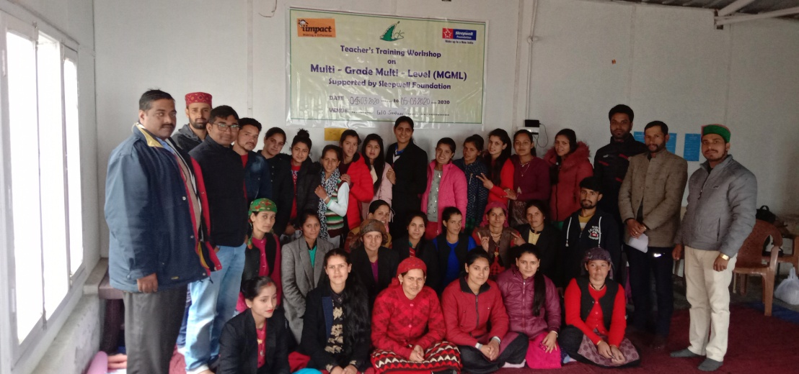
Teachers are the key to meaningful learning and education selected from local villages itself after well laid down process. An education system succeeds or fails due to quality of its teacher. Therefore, valuing and investment in teachers is a necessity. IDS has conducted quarterly teachers training workshops seeking to improve teacher's subjective knowledge and innovation in teaching skills. The teachers are also trained is issues like health, hygiene, nutrition, and environmental sanitation including preparation of learning material. The no of trainings conducted is given below.

S.N. | Name of district | No of Training | No of participants
1 | Dehradun | 2 | 56
2 | Uttarkashi | 2 | 65
 |  | 4 | 121

Community mobilization and meeting

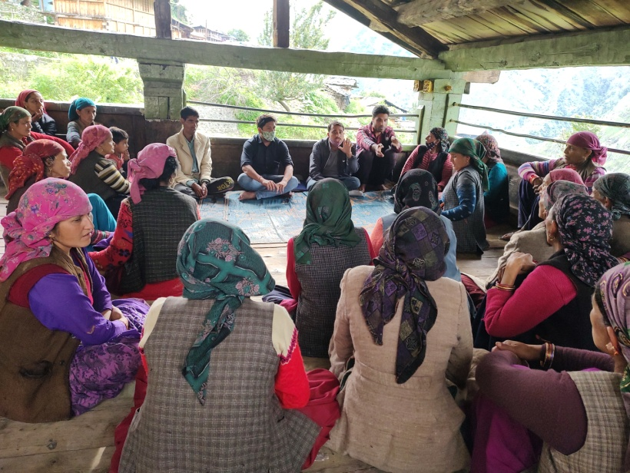
Center Management Committee (CMC) is organized by IDS for the management of each and every learning center. The parents and members of village community are the members of the committee. Interaction meeting with the larger community members is a regular activity to ensure participation in educating girls. The main aim of the meetings is to discuss the academic progress of the children as also attendance issues with the parents. Parents are also provided orientation on various aspects of their children's development. Apart from academic discussion, issues related to child protection, health, nutrition are also discussed so that they can guide their children properly at home to lead a healthy life. The CMC also provides infrastructural support to operate the learning center. The no of CMC meeting are conducted is given below.

S.N. | Name of district | No of meeting | No of participants
1 | Dehradun | 153 | 3060
2 | Uttarkashi | 174 | 4321
 |  | 327 | 7381

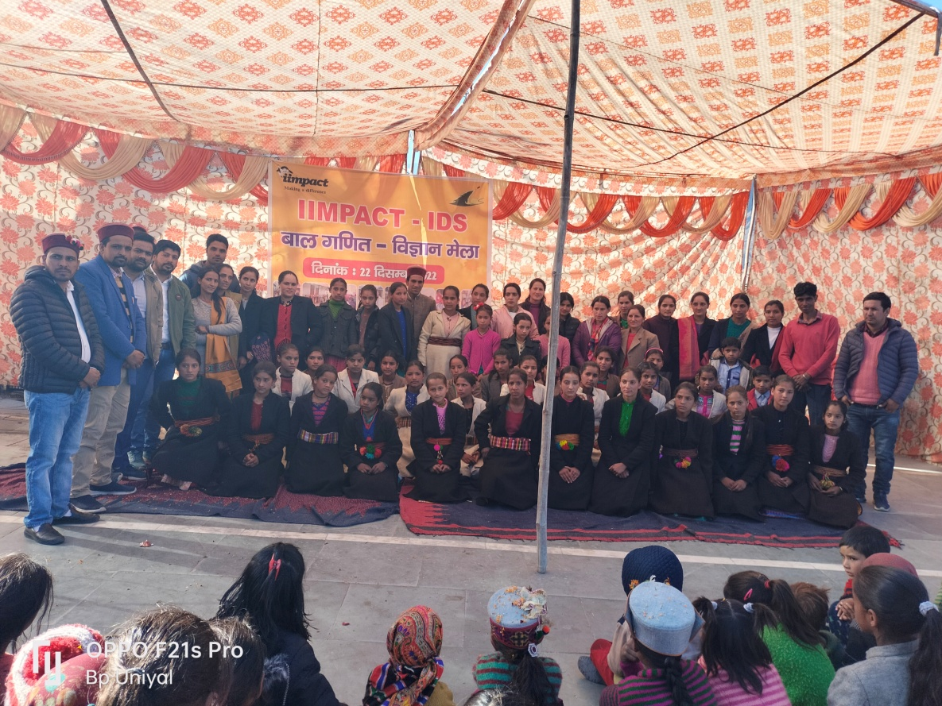
During the unlock down process we started to get permission to promote co- academic activities in the village. We made a batch of 7 and 8 girls of two batches a day and started promoting micro teaching in alternate days in the area. Teachers were instructed to follow the instructions advised in the SOP. They were advised to follow on the social distancing norms, to ensure wearing of masks, and practicing handwashing practicing before and after commencement of the micro teaching sessions. The venue for teaching has been identified other than the learning Centre and no means of learning Centre are utilized during the teaching sessions. Even the girls are advised to bring their own mats, water bottles from their homes. We started the batches only in those areas where we succeeded in getting permission of teaching. We are able to teach the children with around 45-50% of presence of the girls in the micro batches. Proper lesson plan is made by the teachers and same is followed on in the sessions. Due technical assistance is procured by the supervisors, APC and PC during the field visits. However, the number of positive cases of Covid-19 are increasing day by day and there is sense of insecurity against spreading this virus in the area. Hence, stringent Covid-19 protocol is followed on with the adherence of government guidelines. We have advised our field staff if anybody is found positive in the area and they were in the contact with them should be made quarantine at any cost and they should cease any co academic areas in those circumstances. We aimed to encourage the co academic activities in the area so that the process of learning could not be ceased up. In order to make the community connect frequent door to door visits are organized and issues pertaining to the same are discussed during the interpersonal communication.

